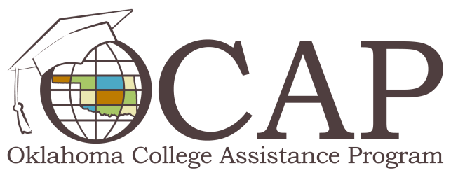
Don’t Get Swindled by Scary Scams
Despite heightened awareness from media attention, millions of consumers fall victim to money-stealing scams every year. This fall, guard your money so that you can reap financial treats and avoid costly tricks. Beware of the following scary schemes and remember there are many more out there.
- Check overpayment scams. This con generally targets consumers who sell items through classified ads or online auctions. The scam begins when the buyer replies to an ad and offers to purchase the item with a check. The buyer comes up with a reason for writing the check for more than the purchase price, and asks the seller to wire back the difference. Later, the check bounces, leaving the seller liable for the entire amount. To avoid this rip-off, refuse to accept any checks for more than the asking price and never agree to wire funds back to the buyer.
- Fake charities. Charitable giving tends to thrive as the holidays approach. Unfortunately, so do scam artists who are willing to take advantage of the kindness of others. To ensure your gifts truly go to those in need, check nonprofit monitoring websites like Guidestar.org or CharityNavigator.org.
- Jury duty scam. In this tricky scheme, someone claiming to work for the local court calls to inform victims that they've failed to report for jury duty and a warrant has been issued for their arrest. The caller then asks for the victims' personal identifying information, like Social Security numbers, birth dates and sometimes financial information, for "verification" purposes. This scam plays on the victim's fear of going to jail, so stay on-guard and remember that court employees won't call you to verify your information. If in doubt, hang up and call the courthouse using the number listed in the phone book or on their website.
- Mortgage modification scams. These scams prey on homeowners who are on the brink of foreclosure. Though the federal government created programs and authorized agents to counsel homeowners through the process, unauthorized companies and individuals have gained the trust of vulnerable homeowners while scamming them out of their money. To avoid being victimized, homeowners should visit MakingHomeAffordable.gov or call 1.888.995.HOPE for more information about mortgage loan modification options and other available programs.
To learn more about protecting yourself from common scams and schemes, browse the Federal Trade Commission's Scam Alerts webpage at Consumer.FTC.Gov/Scam-Alerts.

