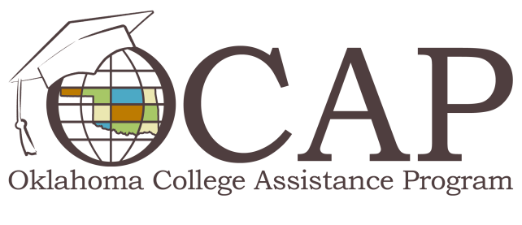

Repayment Ready
Graduating from college is one of the most rewarding lifetime achievements, but stress about repaying student loans can put a damper on the celebration. You can alleviate this stress by taking control of your loan repayment process. Here’s what you need to know:
- Know the process. Student loan repayment begins after your six-month grace period expires or when you drop below halftime status, leave school or graduate. The Master Promissory Note (MPN) is a legally binding contract that obligates you to repay your loan. You’ll learn about this contract and your rights and responsibilities during your exit interview.
- Communication is key. You should stay connected with your loan holder(s) and share current contact information, such as a change in your name, phone number, mailing address and email address. Payment arrangements can be made if you’re unable to make monthly payments, but you must ask for help.
- Utilize available resources. The National Student Loan Data System (NSLDS) maintains federal student loan data, including your lender and servicer contact information, loan types and loan amounts. Your Social Security number, date of birth and FSA ID are required to access NSLDS.
Repayment options were created to lessen the financial burden during tough economic times. If you’re experiencing financial hardship, you have several options to choose from:
- Forbearance. Loan holders may grant forbearance if you’re experiencing financial difficulties. During forbearance, you’re charged interest on subsidized and unsubsidized loans, which will be added to your principal loan amount.
- Deferments. You may postpone loan payments for specific situations, in which time limits and eligibility requirements apply. The government will pay the interest that accrues on subsidized loans during a deferment.
- Repayment Plans. Your repayment amount and length of time are determined by your loan amount and repayment plan the borrower chooses. You can avoid the pitfalls of delinquency and default by selecting a repayment plan that best fits your budget.

  - Standard Repayment Plan – allows you to pay off loans within 10 years to minimize interest cost.
  - Graduated Repayment Plan – payments start lower and gradually increase as your income increases. This plan also includes a 10-year repayment term.
  - Income-Sensitive Repayment Plan – based on your current income (each payment must be enough to cover accruing interest). This plan is only available for Federal Family Education Loan Program (FFELP) loans.
  - Income-Contingent Repayment – based on your annual income, family size, and your total loan amount. Payments may change as your annual income changes. This plan is only available for Direct Loans from the U.S. Department of Education.
  - Extended Repayment Plan – you must have a balance of at least $30,000 to qualify for this plan and must repay the loan within 25 years.
  - Income-Based Repayment Plan – based on your annual income and family size with a repayment term of 20 or 25 years depending on when you took out your loans. After 20 or 25 years, your remaining debt is forgiven.
  - Pay as You Earn – you must be a new Direct Loan borrower on or after Oct. 1, 2007 and receive a new loan on or after Oct. 1, 2011. You must have a partial financial hardship based on annual income and family size. After 20 years of eligible payments, your remaining debt is forgiven.
  - Federal Loan Consolidation – allows you to combine loans into a single monthly payment. Your repayment term can be up to 30 years.
There’s a wide variety of options available to help you successfully manage your student loan debt. Visit ReadySetRepay.org for more information.

