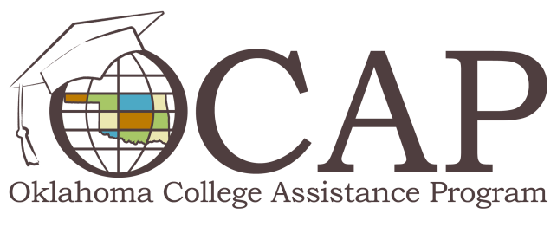

The Benefits of Paying Student Loan Interest While In School
Every semester, students take out loans to help pay educational expenses throughout the school year. Without these loans, many students wouldn't have the funds to continue their education. Generally, the last thing on their minds is repaying any portion of their loans before they absolutely have to do so. However, interest payments on student loans are generally affordable on a college budget, and those small payments can make a big difference in the amount repaid over the life of a loan.
What would happen to students' repayment schedules over time if they paid the interest on their education loans while they were still in school? Let's take a look at Jim and Jane.
Jim and Jane met at Iwanna Job University in a freshman English class. They hit it off, and before long, Jim and Jane planned to marry after graduation. Jim and Jane started discussing how they'd join lifestyles and combine belongings such as furniture, kitchenware, pets and finances. As they talked about their student debt, Jim and Jane discovered that while they'd both borrowed $25,000 ($3,125 unsubsidized each semester for 8 semesters at 6.8 percent interest), Jim's loan balance of $29,462.50 was higher than Jane's balance of $25,000. Why? Jane paid her interest expenses each month during school.
How did Jane's regular interest payments affect her loan repayment as compared to Jim's?
- Because it wasn't paid in advance, the interest on Jim's student loan was capitalized into the original amount he borrowed. This means that Jim effectively borrowed $29,462.50.
- Jim's monthly payment under the standard repayment plan is $339.06, while Jane's monthly payment is $287.70. Jane's payment is over $50 less each month!
- Jane's total repayment (including her in-school interest payments) will be $38,579.31, while Jim's total repayment will be $40,686.65, a difference of more than $2,100.
(Standard Loan Repayment Calculations made using FSA's student loan repayment website.)
Here's the bottom line: Jim and Jane borrowed the same amount in student loans, but by making interest payments while she was in school, Jane reduced both the total amount repaid and her monthly payment over the life of her loan. For more information about smart borrowing and successful loan repayment, check out ReadySetRepay.org.

