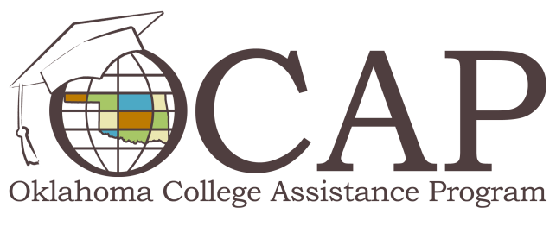

Loan Forgiveness Programs
In these challenging economic times, you may see loan forgiveness as a potential solution for your student loan debt woes. However, it’s important to understand that forgiveness of all or part of your student loan is rare and happens under very specific circumstances. Helpful information about loan forgiveness and repayment programs is provided below.
Corporate Repayment
Many private companies offer cash bonuses designed for student loan repayment in order to compete for skilled workers. Ask about your employee benefits, including student loan forgiveness. You’ll need to find out how long you have to stay with your company in order to qualify and what portion of your loan will be forgiven.
Federal Loan Forgiveness
The federal government offers loan forgiveness in certain industries that struggle to attract talented employees. All federal forgiveness and repayment programs are subject to availability of funds.
Teacher Loan Forgiveness
Teachers who work in Title I schools for five years may qualify for up to $17,500 in Stafford loan forgiveness. Learn about qualifications at ReadySetRepay.org/repaying/tlf.html.
Public Service Loan Forgiveness
If you have Direct Loans and work full-time in a qualified public service job, you may qualify for loan forgiveness after you’ve made 120 consecutive, on-time full payments. If you have FFELP or Perkins loans, you may be eligible for consolidation into the Direct Loan program to take advantage of this option. For more information, visit studentaid.ed.gov/PORTALSWebApp/students/english/PSF.jsp.
Faculty Loan Repayment
Health professions faculty from disadvantaged backgrounds can receive as much as $40,000 toward repayment of student loans in exchange for educating tomorrow's clinicians. To participate, you must agree to serve on the faculty of an accredited health professions college or university for two years. For more information, visit hrsa.gov/loanscholarships/repayment/faculty/.
Indian Health Service Loan Repayment
Commissioned Corps, Civil Service and Direct Tribal Hire employees working full-time for Indian Health Service (IHS), Tribal or Urban Health programs are eligible to apply for an IHS Loan Repayment Program (LRP) Award. To receive an LRP award, you must agree to work for two continuous years in full-time clinical practice at that facility or in an approved Indian health program from the date an award is made. Learn more at www.ihs.gov/careeropps/loanrepayment.
Veterinary Loan Repayment
The Veterinary Medicine Loan Repayment Program will pay up to $25,000 each year toward qualified educational loans of eligible veterinarians who agree to serve in a National Institute of Food and Agriculture (NIFA)-designated veterinarian shortage area for a period of three years. For more information, visit nifa.usda.gov/nea/animals/in_focus/an_health_if_vmlrp.html.
Other health profession repayment programs include:
- National Health Service Corp: nhsc.hrsa.gov/loanrepayment/
- Navy Health Professions Loan Repayment Program: med.navy.mil/sites/navmedmpte/accessions/Pages/LoanRepayment.aspx
- Nursing Education Loan Repayment Program: hrsa.gov/loanscholarships/repayment/nursing/index.html
- National Institutes of Health Loan Repayment Programs: lrp.nih.gov/
Military Loan Repayment Programs
Individual branches of the military may offer loan repayment incentives for service members. Programs are branch-specific; if you’re interested, you should contact branch officials to learn more.
Volunteer Service Awards
If you dedicate a year or more in service to programs such as AmeriCorps, Peace Corps or Volunteers in Service to America (VISTA) programs, you could receive education awards to help repay your qualified student loans or to pay further education costs. Learn more at nationalservice.gov.
If you want to pursue loan forgiveness programs, you must take an active role in educating yourself about the qualifications and requirements, particularly for programs that require employment in a certain location and/or for a specific length of time. More information and helpful links are available on Ready Set Repay’s Student Loan Discharge and Forgiveness Web page.

