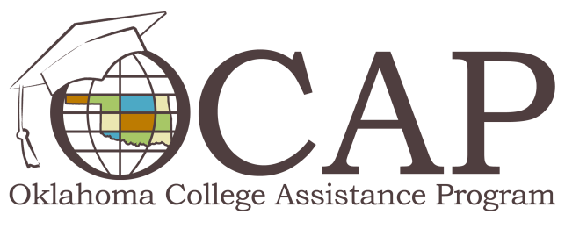

Income-Based Repayment
The Income-Based Repayment plan (IBR), introduced in the College Cost Reduction and Access Act of 2007, was designed to provide relief for borrowers struggling to meet their student loan repayment and other financial obligations. To be eligible for this plan, you must demonstrate that your student loan debt is high in relation to your income and family size. Borrowers holding either Federal Family Education Loans (FFEL) or William D. Ford Direct Loans (DL) became eligible for IBR beginning July 1, 2009. IBR features are detailed below.

Affordable Monthly Payments:

If your loans were issued on or after July 1, 2014 – monthly payments may not exceed 10 percent of your discretionary monthly income
- Monthly loan payments may not exceed 15 percent of your discretionary monthly income, which is helpful if your family is struggling to balance a household budget.
- Monthly payments will be less than the installments for a 10-year standard repayment plan and other repayment plans. You are required to provide your lenders/loan holders documentation to substantiate your income and family size each year.
This chart illustrates the monthly payments for a borrower with a family size of four.
Annual Salary | $25,000 | $35,000 | $40,000 | $45,000 | $50,000 | $55,000 | $60,000
IBR Monthly Payment | $0 | $18 | $81 | $143 | $206 | $268 | $331

Interest Rate Benefit:
- The government will pay the monthly accrued interest on FFEL and DL subsidized student loans for up to three consecutive years from the repayment date of the loan if the IBR payment doesn’t cover that amount. It’s possible to have a monthly payment as low as $0.

20 or 25-Year Loan Cancellation:
- For loans issued prior to July 1, 2014, if other plan requirements are met, any remaining loan balance after 25 years of satisfactory repayment is considered paid in full. This is the case even if you have made payments of $0 for 25 years.
- For loans issued on or after July 1, 2014, if other plan requirements are met, any remaining loan balance after 20 years of satisfactory repayment is considered paid in full. This is the case even if you have made payments of $0 for 20 years

10-Year Public Service Loan Forgiveness:
- If you’re a public service worker who makes scheduled, on-time monthly payments for 120 months while employed full-time in a qualified public service job, you may receive loan forgiveness. The Public Service Loan Forgiveness Program is available only for DL borrowers. FFEL borrowers will need to complete a DL consolidation loan to participate in this option.
You can visit ED’s IBR Web page to determine plan eligibility and get a monthly payment estimate.

