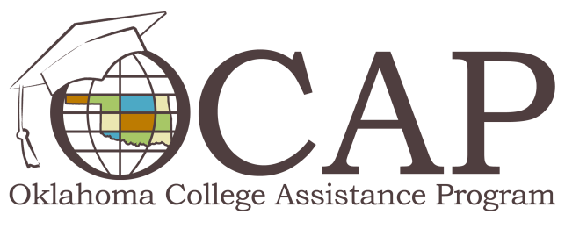

Restoring Eligibility for Financial Aid after a Default
Defaulting on a federal student loan carries heavy consequences, potentially including wage and tax refund garnishment, a damaged credit rating and loss of federal financial aid eligibility. If you have not yet completed a degree, the loss of federal aid can have a significant negative impact on your academic career.
Fortunately, the loss of financial aid eligibility as a result of defaulting on past student loans doesn't have to mean the end of the road to higher education. If you’d like to return to school, but you’ve already defaulted on past student loans, you still have several options.
The Satisfactory Repayment Program allows you to re-establish federal aid eligibility by making full payments each month for six consecutive months. You can't miss a payment during this six month period, and every payment must be made within 15 days of the due date. Wage or tax refund garnishments do not count toward the six consecutive, on-time payments, and you can't pre-pay in lump sums. This program is a one-shot opportunity, so if you are more than 15 days late on one of the six payments or fail to maintain satisfactory repayment after regaining federal aid eligibility, access to federal aid funds will be revoked and you will not be able to receive aid through the Satisfactory Repayment Program again.
Loan Rehabilitation restores your loan to satisfactory repayment status and removes the negative rating on your credit report. Since your loan is no longer in default, you are able re-establish eligibility. Participation in this program requires that you complete a Rehabilitation Application and make nine full monthly payments within 10 months. Each payment must be made within 20 days of the due date for FFEL and Direct Loans and 15 days for Perkins Loans. You can't pre-pay in lump sums, and wage or tax refund garnishments do not count toward the nine payments. You must return the completed Rehabilitation Application to the loan holder before making the ninth payment. Once the loan holder has received your nine on-time, full monthly payments and completed application, your loan will be removed from default.
Loan Consolidation combines all of your federal student loans into one loan with a single monthly payment, which is held by the U.S. Department of Education. Consolidating defaulted student loans will remove your loans from default, restoring federal aid eligibility. To participate in loan consolidation after defaulting on student loans, you must currently be repaying the defaulted loans or agree to either an income-contingent or income-based repayment plan.
If you don't agree to repay under either the income-contingent or income-based repayment plans, you must make at least three consecutive payments within 15 days of the due date before the consolidation can be processed and your loans removed from default. Wage and tax refund garnishment do not count toward the three payments.
Loan consolidation may not be the best option for you. If you’re enrolled in school at least halftime, you’re not eligible to consolidate, but once you are making payments on a consolidated loan, you may once again enroll at halftime or full-time status. Loan consolidation may also increase the amount of interest paid over time, so you’ll want to consider this option carefully.
If you’re interested in re-establishing federal student aid eligibility, but have a student loan default, contact your loan holder to discuss your options. Visit ReadySetRepay.org to learn more about default recovery options.

