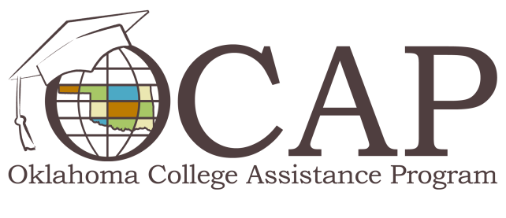

Preparing for Successful Repayment
Student loan default is on the rise, so it's more important than ever to arm yourself with the knowledge and resources that will help you successfully manage your student loan obligations.
Successful student loan repayment begins with knowing how much you owe and who is servicing your loan(s). The U.S. Department of Education now has a "MyStudentData Download button" on the National Student Loan Data System (NSLDS) Student Access website NSLDS.ed.gov. You can use this tool throughout your college career and into repayment of your loans. The MyStudentData Download button allows you to receive loan data in a simple text file, rather than limiting the data view to a webpage or PDF file. The text file includes your federal loan and grant amounts and disbursement amounts, loan servicer information, and enrollment and overpayment information.
If you have questions about the MyStudentData Download button, contact the Federal Student Aid Information Center at 800/4-FED-AID (800/433-3243), 800/730-8913 (TDD/TTY) or FederalStudentAidCustomerService@ed.gov.
ReadySetRepay.org provides valuable information regarding student loan repayment, including a Loan Calculator that allows you to estimate monthly payment amounts based on a standard ten-year repayment schedule. This information can help you create a budget and prioritize your spending. Based on your standard monthly payment estimate, you may want to look into different repayment options, consolidation, deferment or forbearance.
Defaulting on student loans leads to serious consequences, but successful repayment will help you build a solid credit record and create good financial management habits. Educate yourself about your many debt management options to get on the path to successful student loan repayment.

