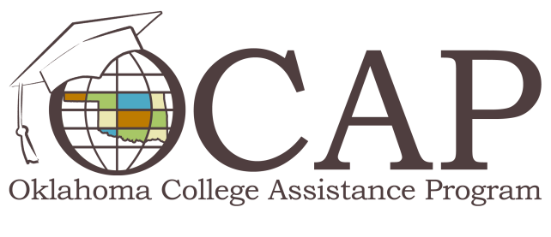

Federal Student Loan Grace Periods
Federal student loans offer you some of the best loan options to finance your college education once you’ve exhausted any free money, like scholarships and grants, available. Unlike most private market loans, federal student loans provide a grace period, which provides you with a set period of time to prepare for loan repayment before you’re required to make payments.

Know and Understand Your Grace Period
Your grace period begins after you graduate, once you withdraw from your institution, or when your course enrollment drops below halftime. Remember, during a grace period, you are not required to make loan payments. The lengths of grace periods vary depending on the type of federal student loan.
- Perkins loans have a 9-month grace period.
- Subsidized Stafford loans have a 6-month grace period.
- Unsubsidized Stafford loans have 6-month grace period.
- For Graduate PLUS loans disbursed on or after July 1, 2008, payments can be deferred for an additional 6-months (if borrower is a parent PLUS borrower and also a student).
- For PLUS loans first disbursed on or after July 1, 2008, payment can be deferred for an additional 6-months (if the student for whom the loan was obtained is enrolled at least halftime).
Keep in mind that the majority of federal student loans accrue interest during the grace period. While some subsidized Stafford loans have an interest subsidy during the grace period, subsidized Stafford loans originating between July 1, 2012 and June 30, 2014 will not include an interest subsidy for grace periods. If possible, make monthly interest payments during your grace period, otherwise the interest will capitalize and be added to the principal of your loan.

A Grace Period Checklist for Tackling Student Loan Debt
While it’s always a good idea to start thinking about your student loans ahead of time, many students don’t begin thinking seriously about their student loan debt until leaving school or after graduation. Fortunately, the grace period is a great time to get ready for repayment. Here is a checklist of things you should do during the grace period:
- Get organized. Create a ‘my student loan’ file and place important loan documents and lender correspondence in it.
- Review current monthly expenses and adjust your monthly budget to accommodate a student loan payment.
- Research your federal student loans on the National Student Loan Database System (NSLDS) website at NSLDS.ed.gov
- Research student loan repayment options and choose the best repayment schedule for your financial situation.
- Contact your lender(s) to discuss the terms and conditions of your student loans. Ask questions about anything you don’t understand.
- Set up automatic monthly payments. If payment is automatic, it won’t be late!
- Pay extra when possible; the extra money will go toward the principal, which will reduce the amount of interest paid over the life of the loan.
- Stay in touch with your lender(s). Make sure your lender(s) have your most current contact information so you don’t miss a statement or important letter because the lender(s) can’t find you.
If you are worried about not being able to pay, keep in mind: lenders will work with you to resolve repayment concerns. If you are having trouble making payments because of unemployment, health problems or other unexpected financial challenges, don’t panic; there are options to handle short term financial difficulty. For example, deferment and forbearance options allow for temporary suspension of loan payments. Contact your loan holder(s) for assistance.
Please visit the OCAP Facebook page at Facebook.com/RepaymentScoop to learn more about federal student loan repayment.

